# EVALUATION

The following sections illustrate the testing done to evaluate the Horse Health Monitoring System’s performance and conformity to the design constraints. The subsystems were tested during the process of building the system prototype to make sure the modules worked as planned. Table 4.1 outlines the technical constraints required to be met by the system.

**Table 4.1 -- Technical Design Constraints**

|  |  |
| --- | --- |
| **Constraint** | **Description** |
| Temperature Sensor Accuracy | The temperature sensor must measure the horse’s temperature within a degree Fahrenheit of the rectal thermometer measurement between the range of 90 degrees Fahrenheit and 110 degrees Fahrenheit. |
| Pulse Sensor Accuracy | The pulse sensor must be able to give an accurate heart rate between the range of 25 and 200 beats per minute (bpm). |
| Ingress Protection | The device must adhere to Ingress Protection Rating IP56. |
| Battery Life | The device battery must maintain device operation for a minimum of 12 hours. |
| User Notifications | The device must update the user via text message at certain intervals based upon the user’s discretion as well as alert the user to unusual horse health activity. |

* 1. **Test Certification – Temperature Sensor Accuracy**

The Horse Health Monitoring System’s temperature sensor must be able to measure between a range of 90˚F and 110˚F within one degree Fahrenheit accuracy. The sensor was tested in cool temperatures shown in Figures 4.1.1 and 4.1.2 from the Simrall Hall water fountain on the campus of Mississippi State University.

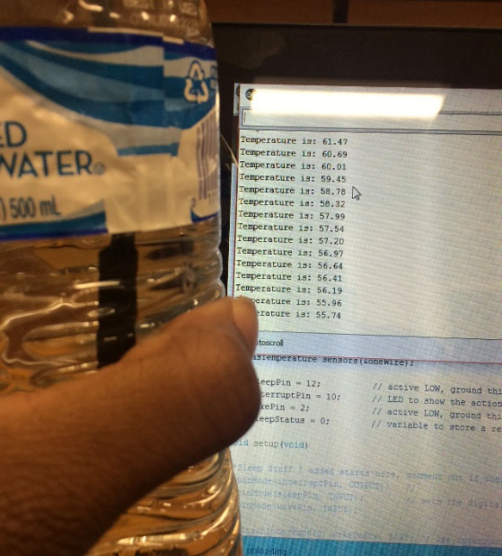

**Figure 4.1.1: Cool Temperature Readings**

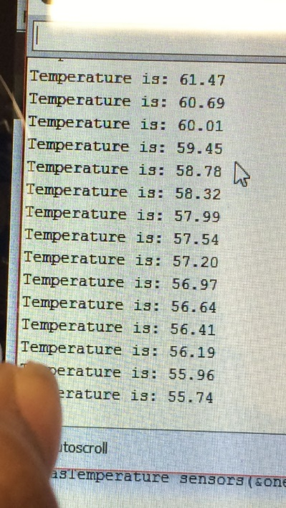

**Figure 4.1.2: Cool Temperature Readings**

The sensor was also tested on human skin to see if the sensor would find a warm temperature value. Figure 4.1.3 represents those temperature results, and Figure 4.1.4 gives a closer look at the temperature readings.

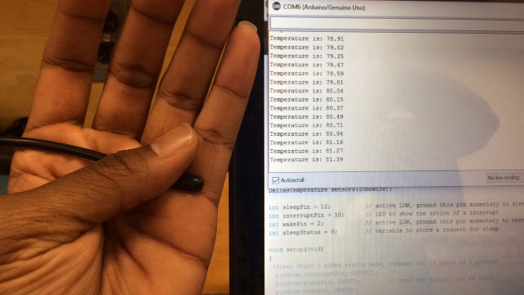

**Figure 4.1.3: Warm Temperature Readings**

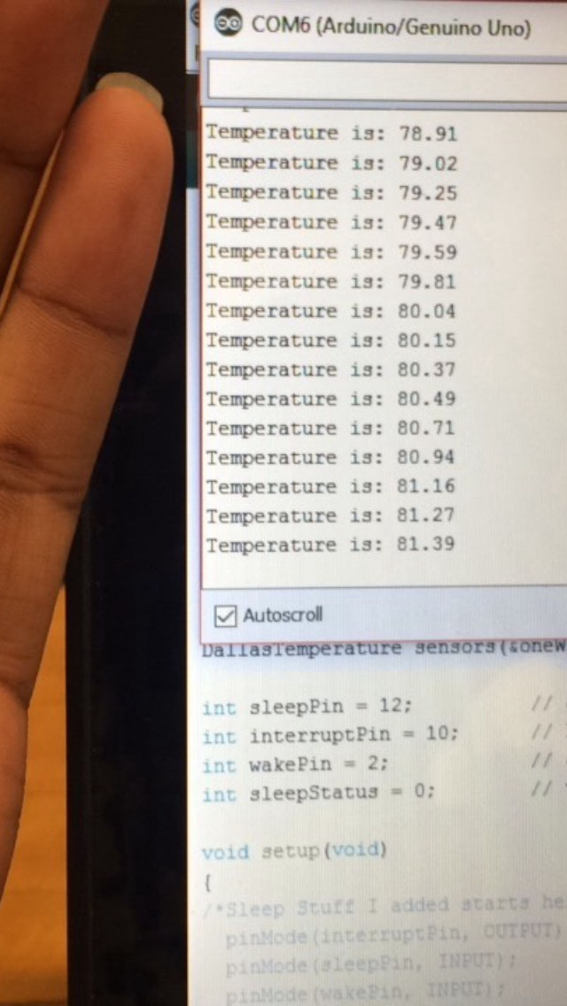

**Figure 4.1.4: Warm Temperature Readings**

Once the device was tested on cool and warm environments, the sensor was tested on a horse a week later. A bandage wrap was used to insulate the temperature probe while it was placed on the horse’s leg so the outside temperature would not affect the readings. The temperature sensor readings were four degrees away from the accuracy of the rectal temperature probe, which needs to be within one degree based on the constraint. Figure 4.1.5 shows the probe placed on the horse’s leg, and Figure 4.1.6 gives a look at the temperate readings given.

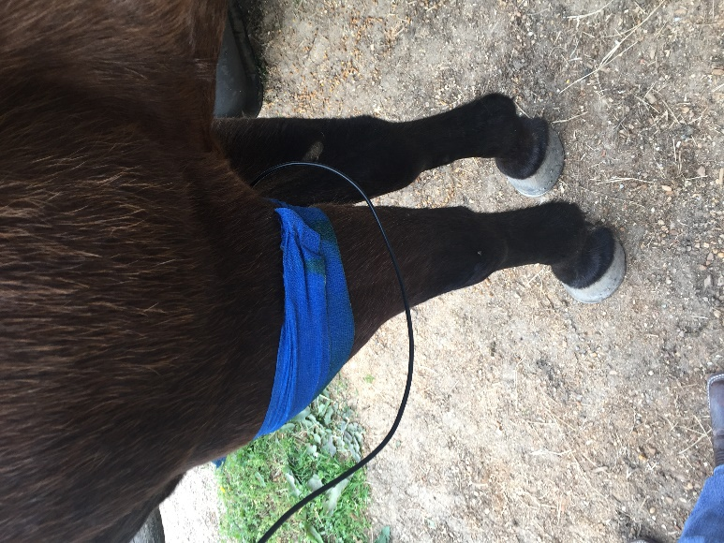

**Figure 4.1.5: Horse Testing**

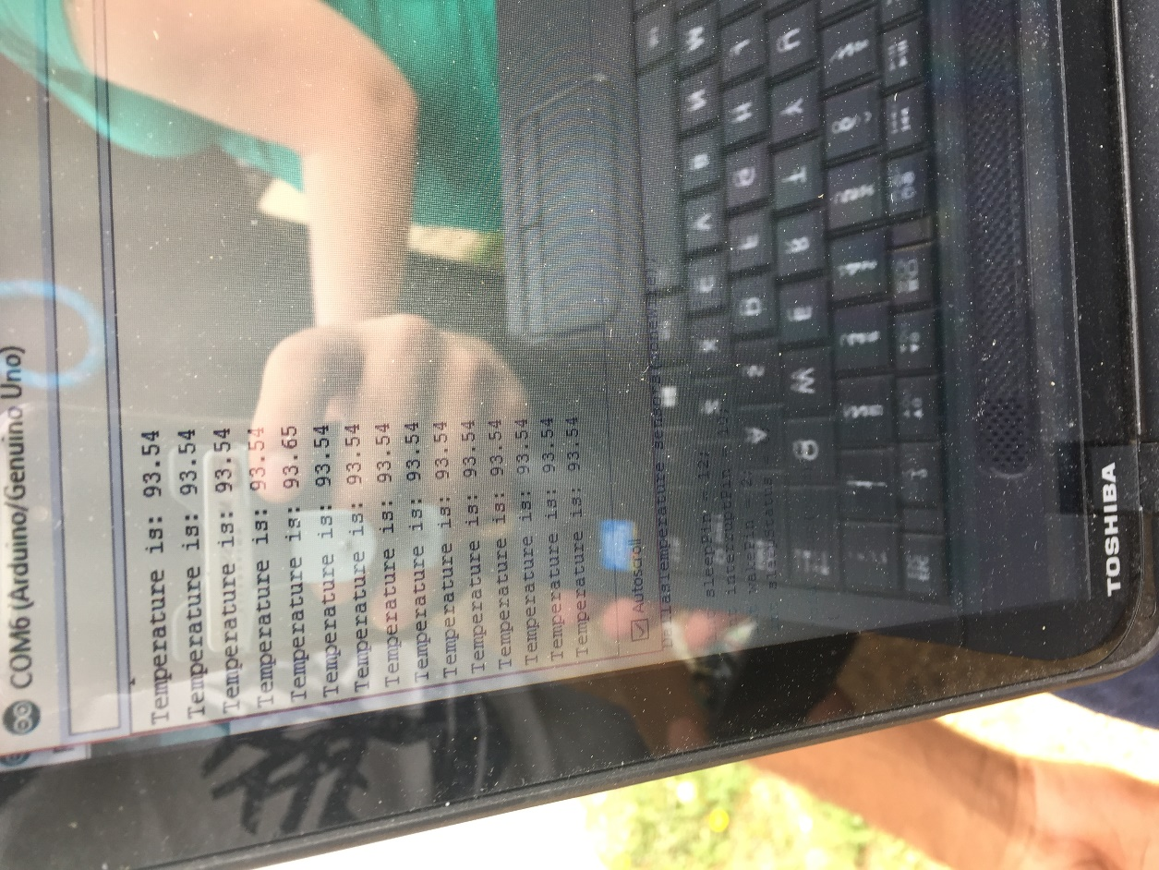

**Figure 4.1.6: Horse Testing**

A second visit to the ranch was conducted to test the sensor against the accuracy of a rectal thermometer, which is shown in Figure 4.1.7. This visit was to ensure that the temperature probe was consistent in its readings. After further testing, an offset was calculated to meet the +/- 1 degree accuracy constraint due to the horse’s thicker skin and hair. During these tests, rather than utilize a bandage wrap, a brace was used to keep the temperature sensor in place.

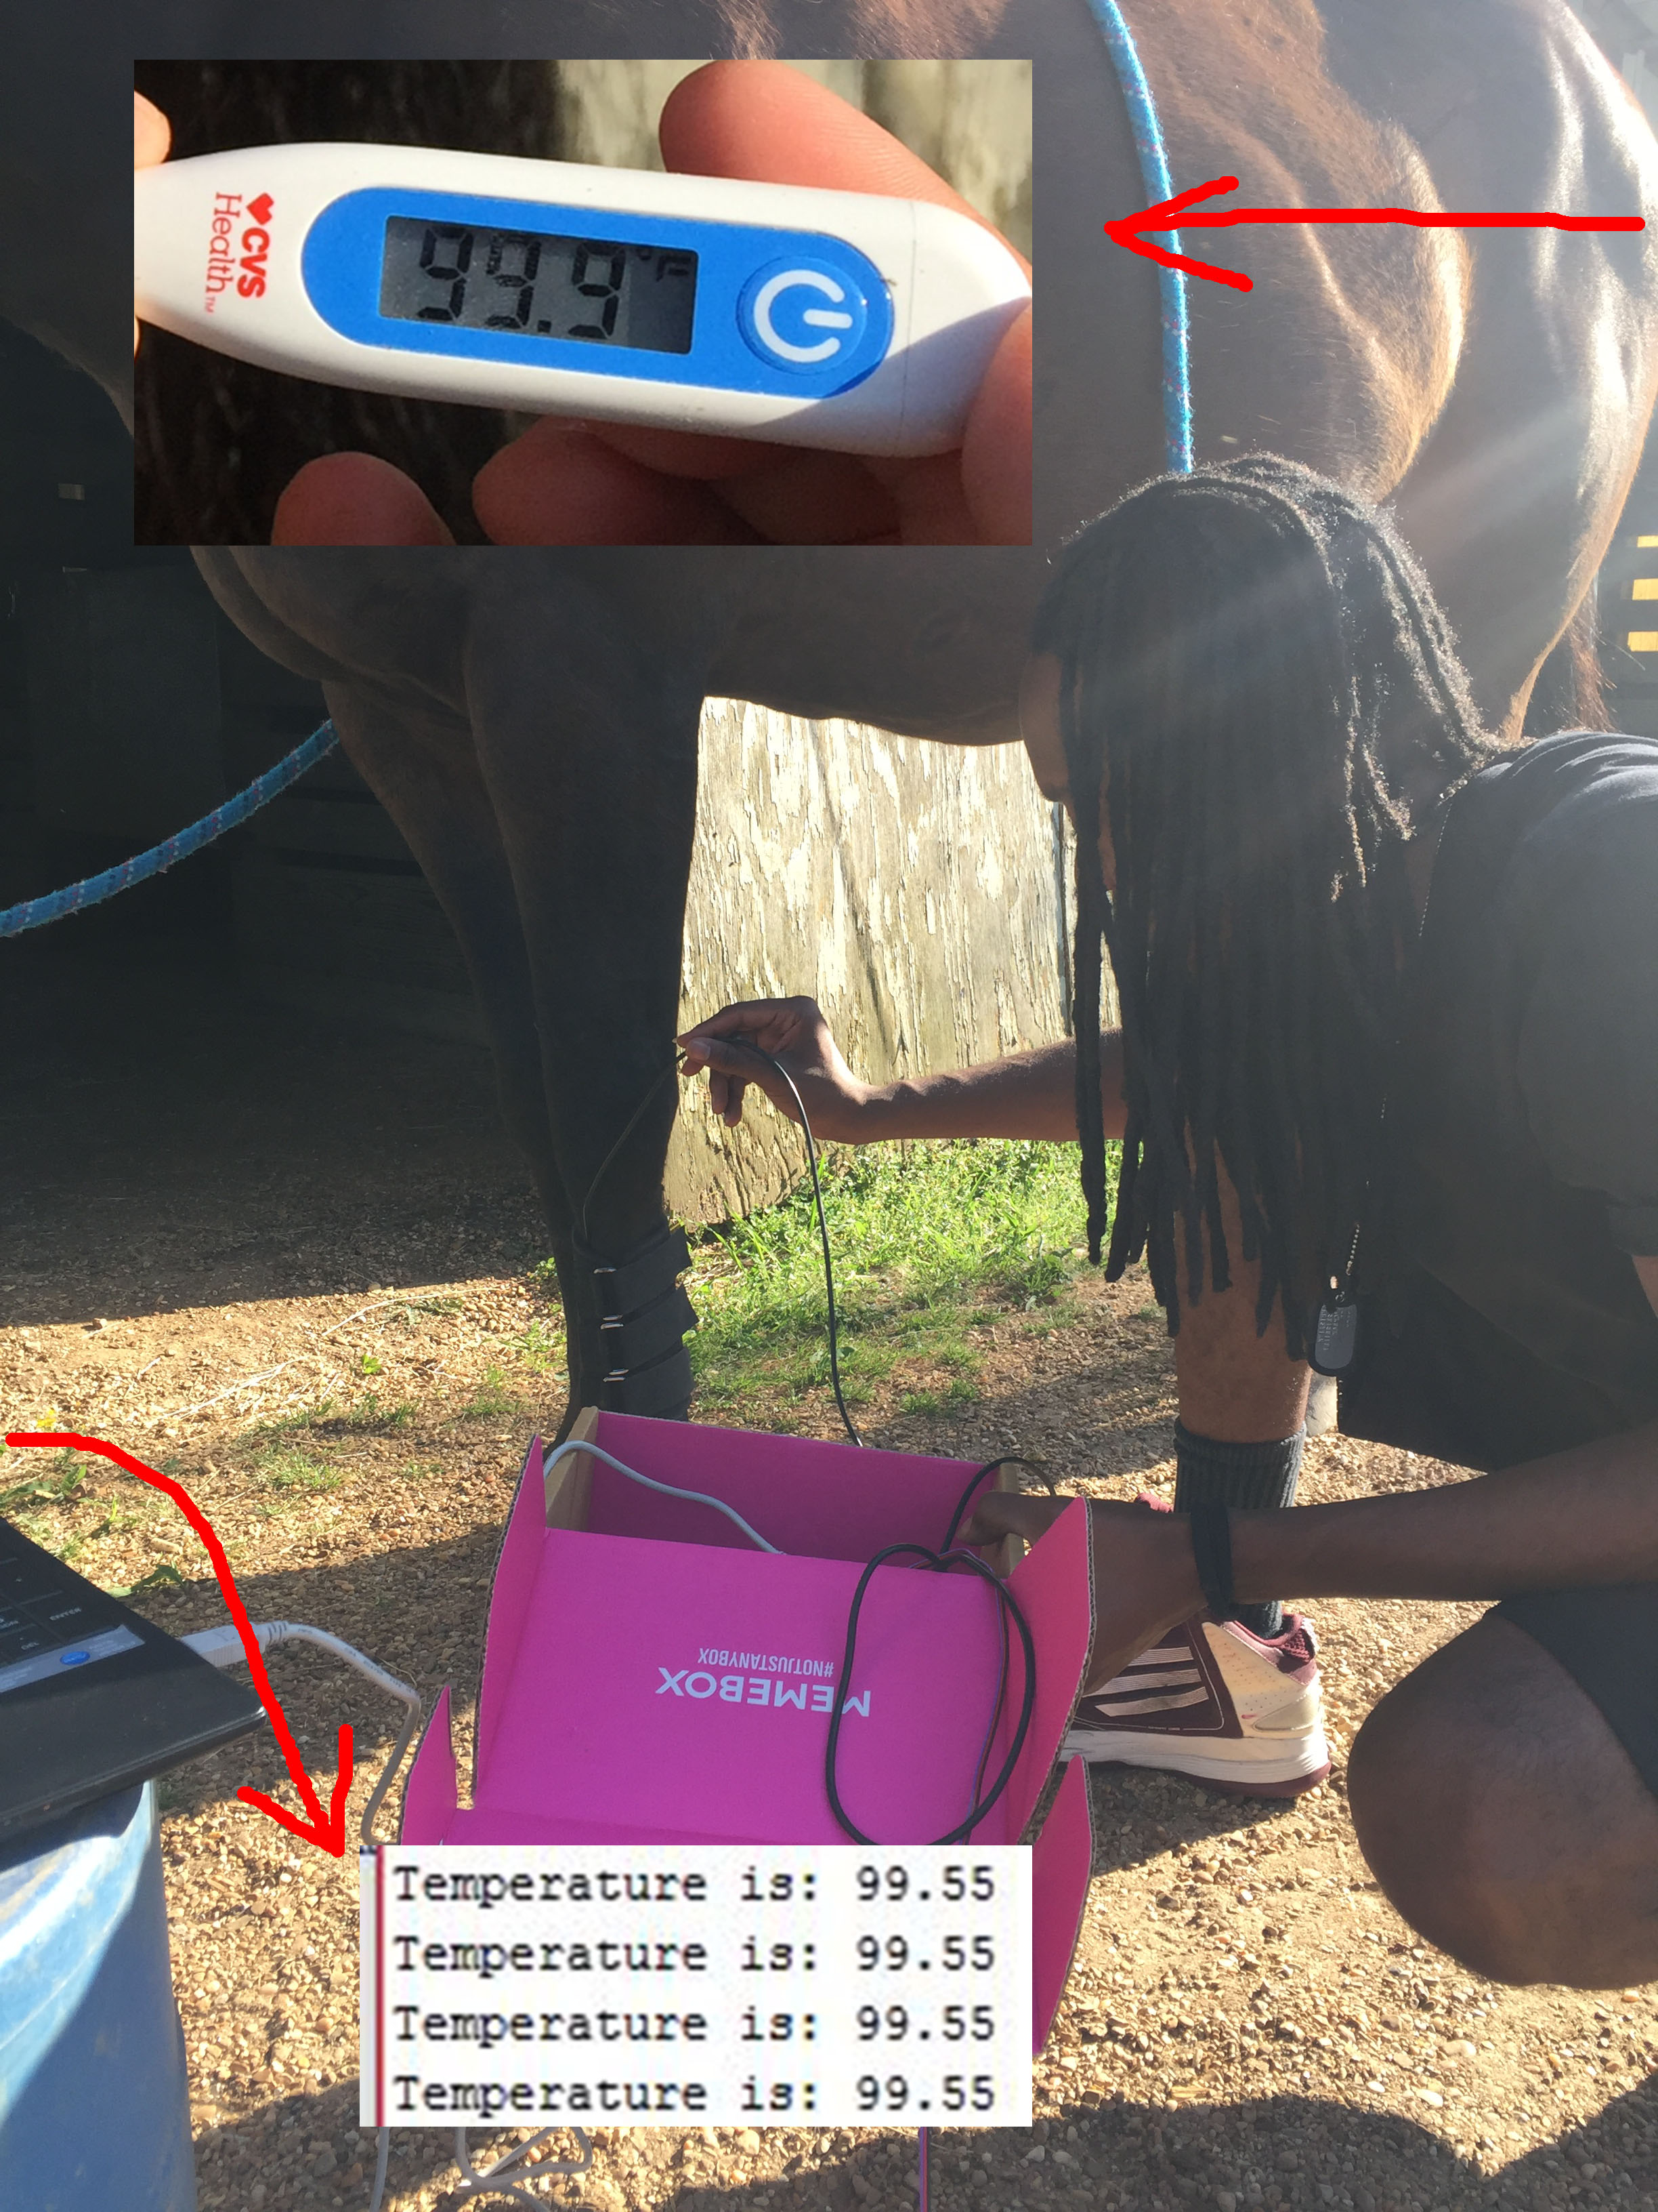

**Figure 4.1.7: Horse Testing**

**4.2 Test Certification – Pulse Sensor Accuracy**

The prototype will incorporate a heart rate sensor to measure the pulse, in beats per minute of the horse. The pulse sensor must give an accurate heart rate between 25 - 200 beats per minute (bpm). The sensor will be placed on the horse’s leg, where the pulse is easy to find, to generate a heartbeat measurement. During the test, the sensor could not find a consistent reading because of its sensitivity. The pulse sensor was previously tested on a team member’s finger and verified through the heart beat measurement of a blood pressure monitor as shown in Figure 4.2.1 and a closer look in Figure 4.2.2.

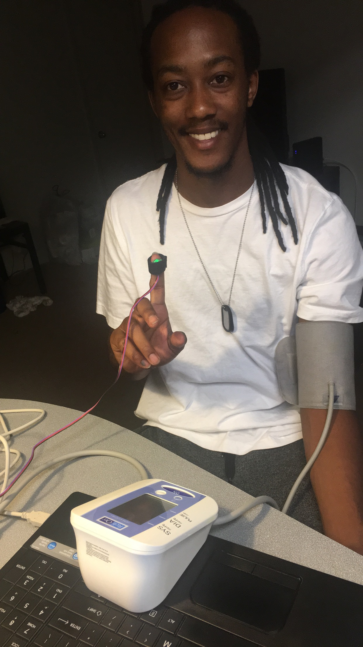

**Figure 4.2.1: Pulse Sensor Testing**

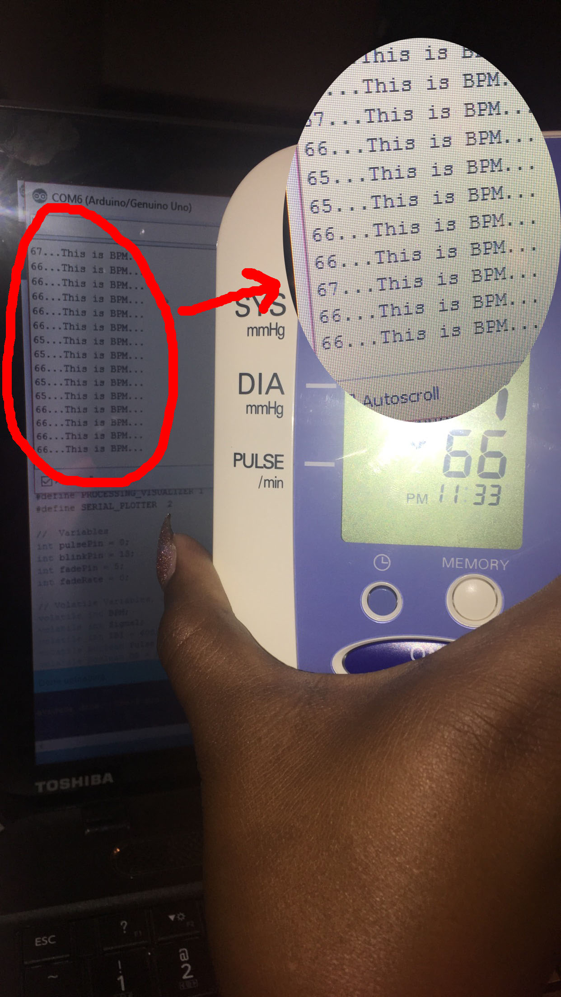

**Figure 4.2.2: Pulse Sensor Testing**

After the accuracy of the pulse sensor was verified, the HHM team visited the ranch to test the system on the same horse. A horse’s pulse rate is between the range of 38 - 50 beats per minute, depending on the size. Figure 4.2.3 illustrates a team member manually measuring the pulse rate while the pulse sensor is also conducting readings on the horse.

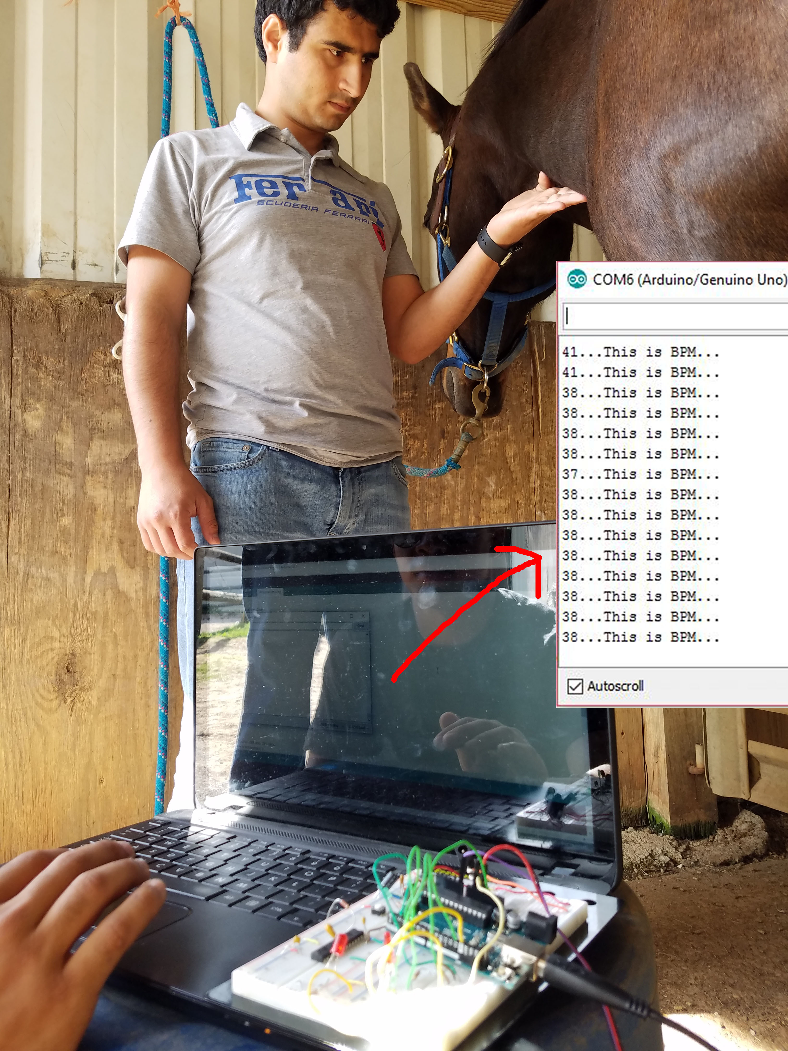

**Figure 4.2.3: Pulse Sensor Testing**

**4.3 Test Certification – Ingress Protection**

The device must adhere to Ingress Protection Rating IP56. The protection states that water and dust must not invade the system in any way possible. This will be tested closely once the prototype is completely packaged. The only component that has been verified to pass this protection rating is the temperature sensor.

**4.4 Test Certification – Battery Life**

The HHM system must be able to operate on battery power for a minimum of 12 hours. To test the longevity of the device, the prototype current was monitored during the sleeping and operating states. At the current state of the design, the system utilizes a B-25-2200-3S1P battery, and the Global System for Mobile Communications (GSM) module utilizes a LP503562 battery. Separate batteries are being used for those two parts of the system due to the current draw requirements of the GSM module. Figure 4.4.1 shows the current draw of the main system, Figure 4.4.2 shows the current draw of the GSM module, and Figure 4.4.3 shows the results of the tests conducted. An image of the two batteries being utilized can be found in Figure 4.4.4.

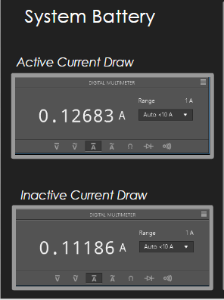

**Figure 4.4.1 System Battery Tests**

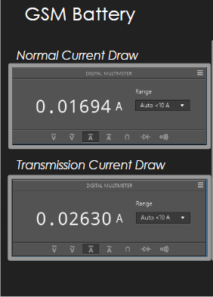

**Figure 4.4.2 GSM Battery Tests**

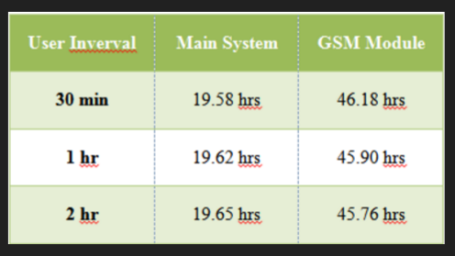

**Figure 4.4.3 Final Test Results**

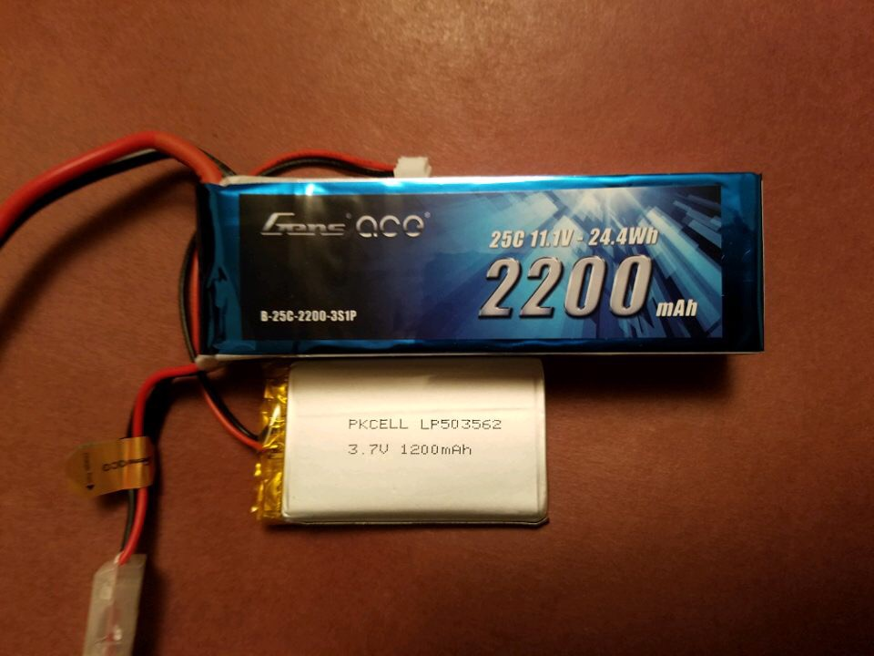

**Figure 4.4.4: Batteries**

**4.5 Test Certification – User Notifications**

The device must update the user via text message at certain intervals based upon the user’s discretion. The user’s phone number and horse name must be programmed onto the device upon device initialization. After the user programs his or her information onto the device, the prototype will text the individual on the user’s defined time interval. Figure 4.5.1 represents how the text messages will be received. The figure shows text message updates every eight seconds with temperature, heart rate, and the next update countdown.

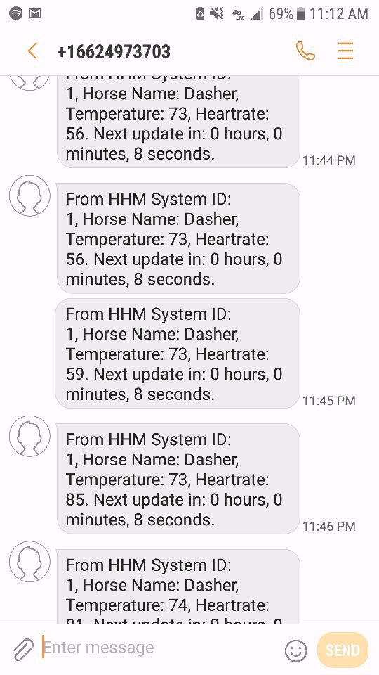

**Figure 4.5.1 Text Messages from System Prototype**